Lab 7

Filter Design and Simulation

Austin Brogan

Performed: 3/20/19

Submitted: 3/27/2019

Interface & Digital Electronics

TAs: Pablo Ordorica, Joseph Panaro, Brendan Wells, Jason Blocklove

Instructor: Raymond Ptucha

**Lab Description**

This exercise consisted of using OrCAD to create and simulate multiple filters using different parameters and frequencies. Passive low pass filters, a Sallen-Key 2nd order low pass filter, second order VCVS (Butterworth) low-pass filter and a biquad band pass filter we all design and simulated and the Butterworth was physically built and tested.

**Circuits and Simulations**

2)

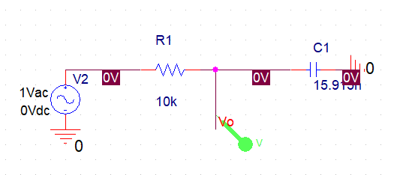

Figure 2.1: Circuit Diagram for Passive Low Pass Filter

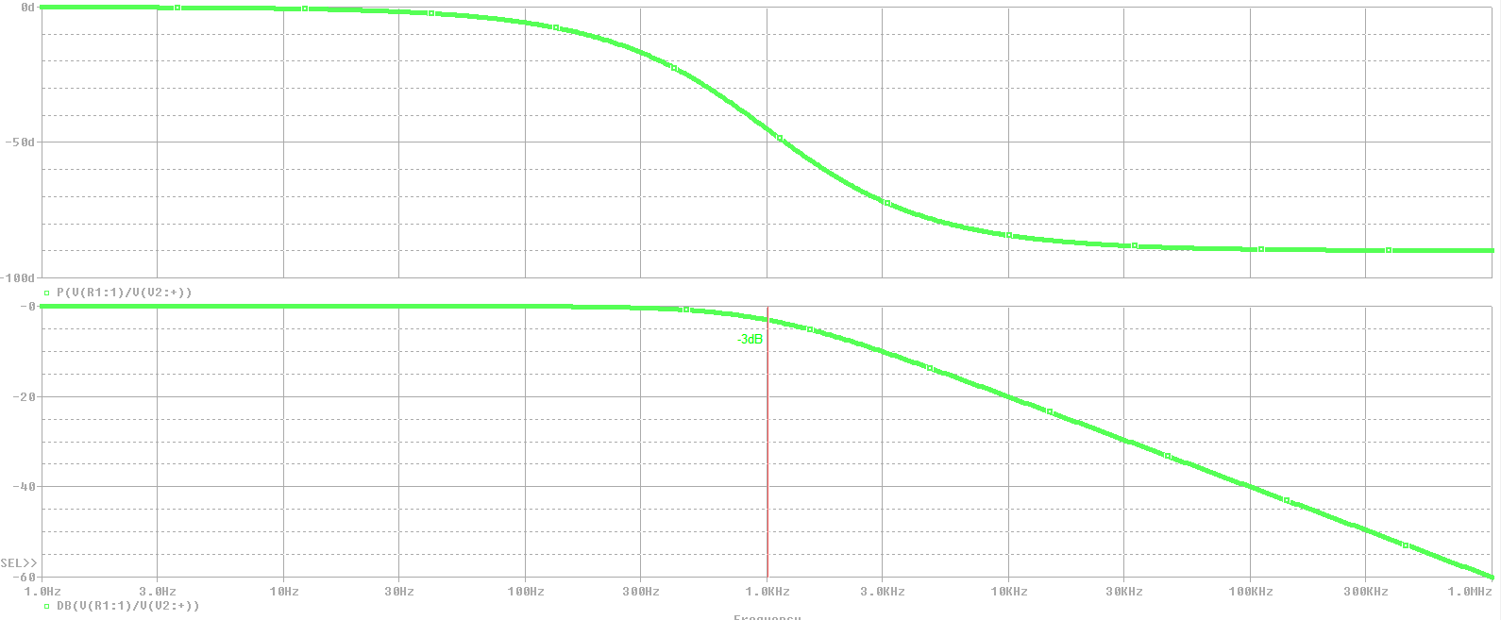

Figure 2.2: Phase Plot (top) and Magnitude Plot (bottom)

3)

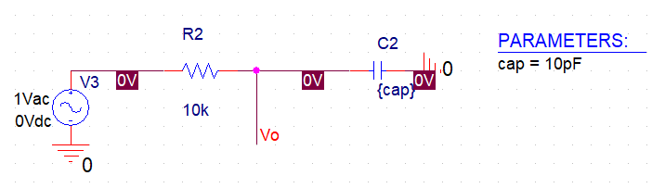

Figure 3.1: Circuit Diagram for Passive Low Pass Filter

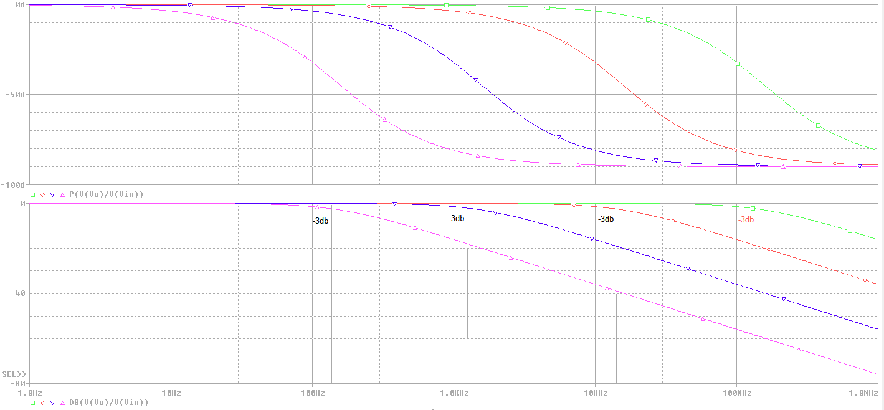

Figure 3.2: Phase Plot (top) and Magnitude Plot (bottom)

The slope of the straight part of each magnitude plot is -20dB/decade.

4)

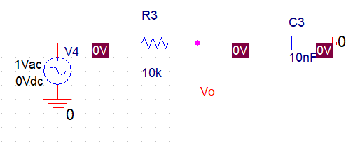

Figure 4.1: Circuit Diagram for Passive Low Pass Filter

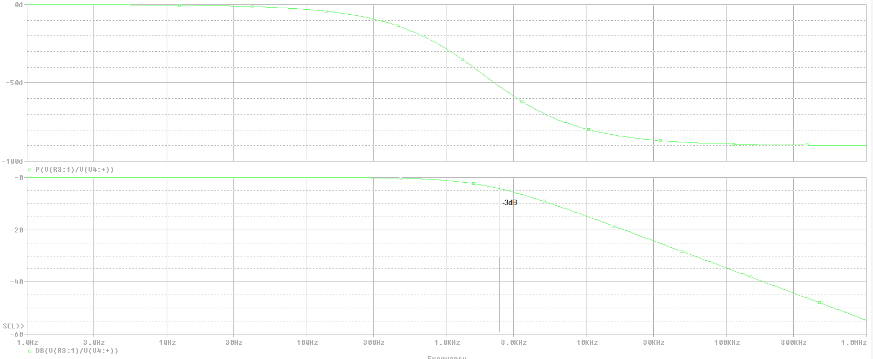Figure 4.2: Phase Plot (top) and Magnitude Plot (bottom)

a) The new f(-3dB) will be roughly 2Hz. R and C for the new stage are and respectively.

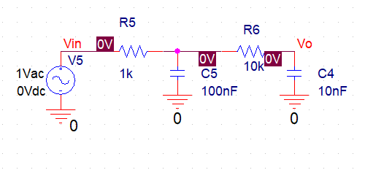

Figure 4.3: Circuit Diagram for Second Order Passive Low Pass Filter

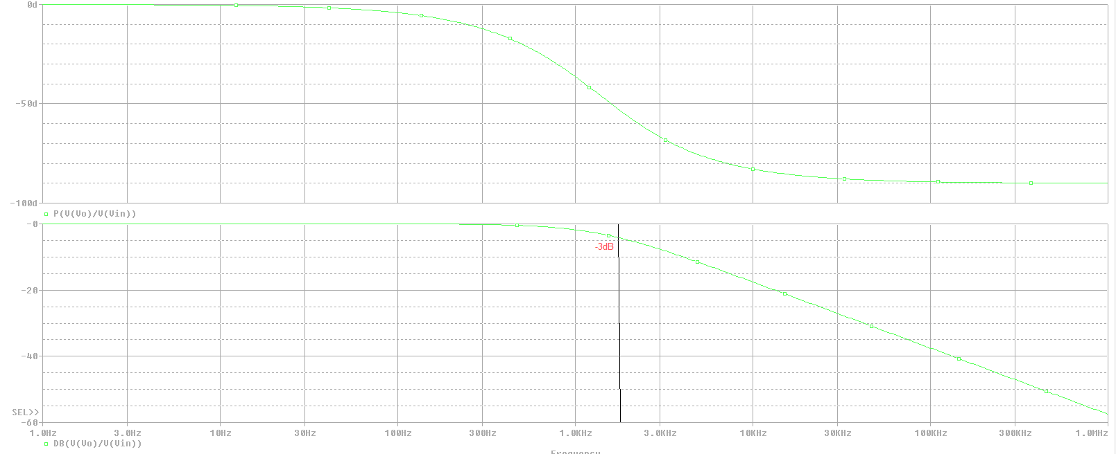

Figure 4.4: Phase Plot (top) and Magnitude Plot (bottom)

b) The new f(-3dB) will be roughly 2Hz. R and C for the new stage are and respectively.

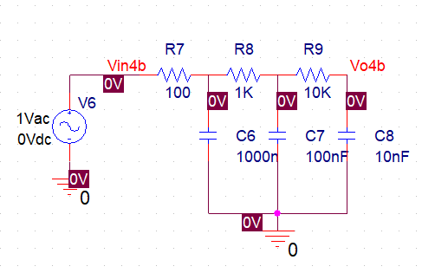

Figure 4.5: Circuit Diagram for Third Order Passive Low Pass Filter

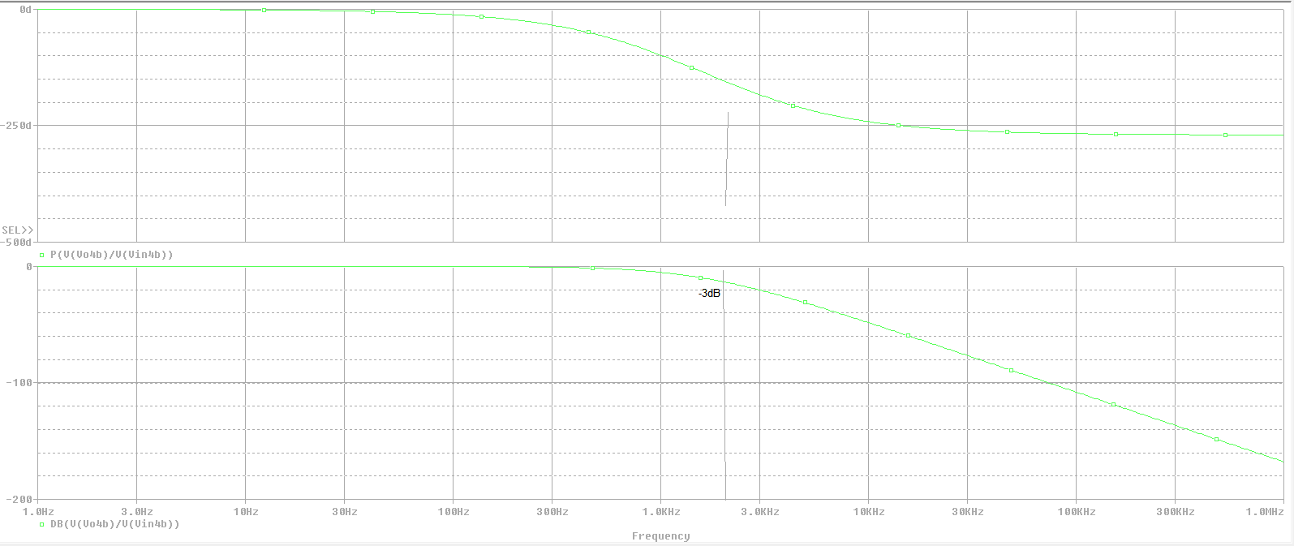

Figure 4.6: Phase Plot (top) and Magnitude Plot (bottom)

c) More stages don’t change the cut off frequency but will scale the magnitude and phase response of the filter.

d) An ideal Op-amp.

5)

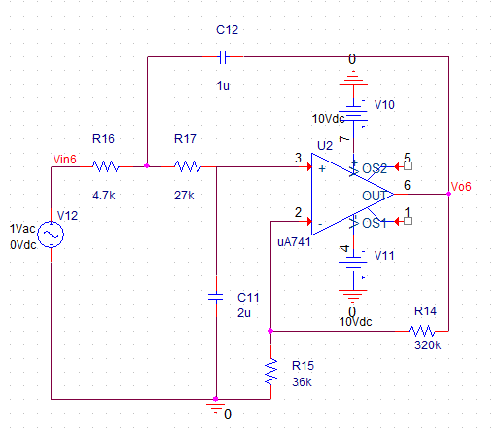

Figure 5.1: Circuit Diagram for Sallen-Key Second Order Low Pass Filter

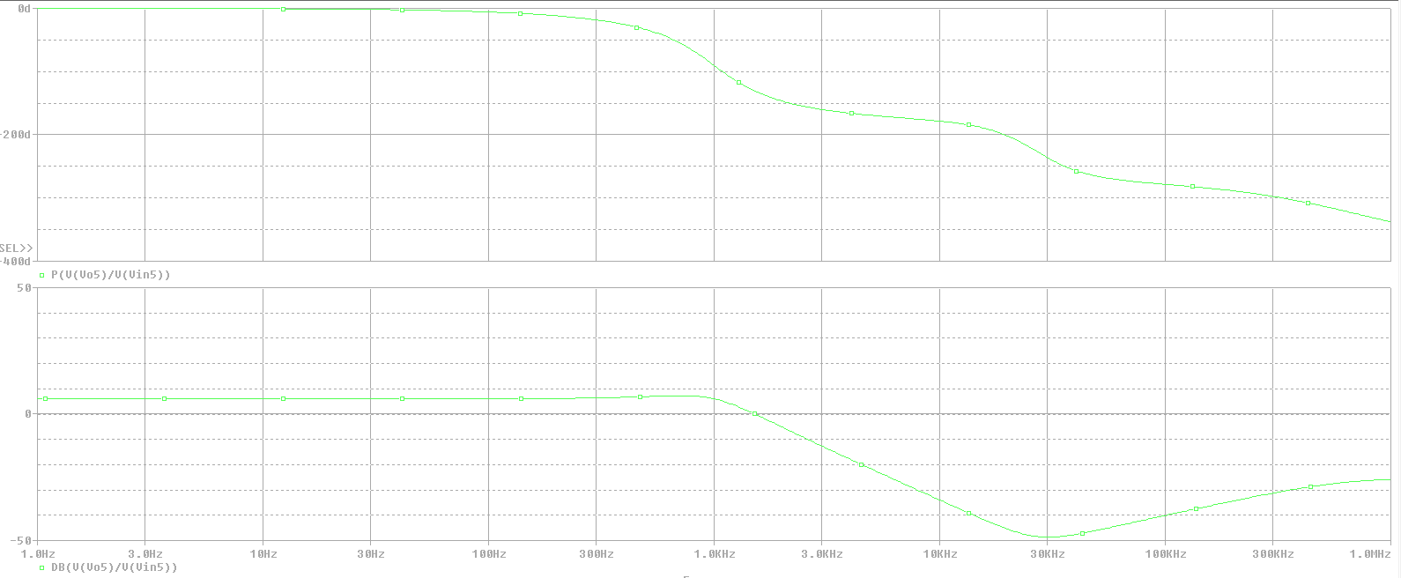

Figure 5.2: Phase Plot (top) and Magnitude Plot (bottom)

6)

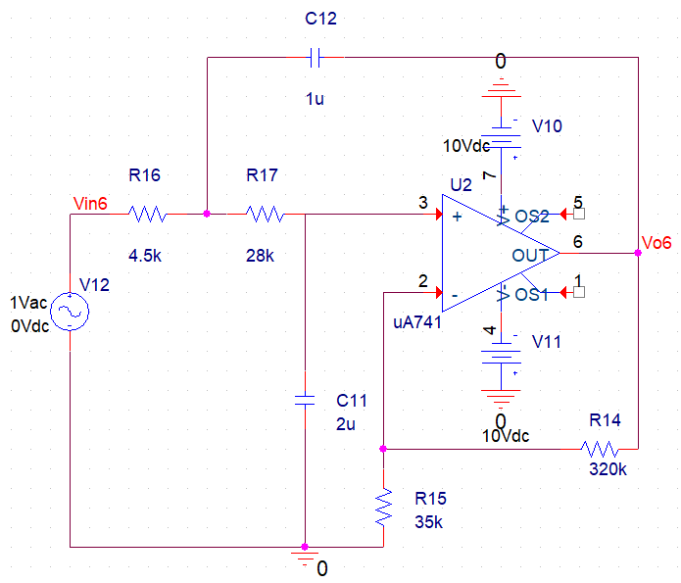

Figure 6.1: Circuit Diagram for Butterworth Second Order Low Pass Filter

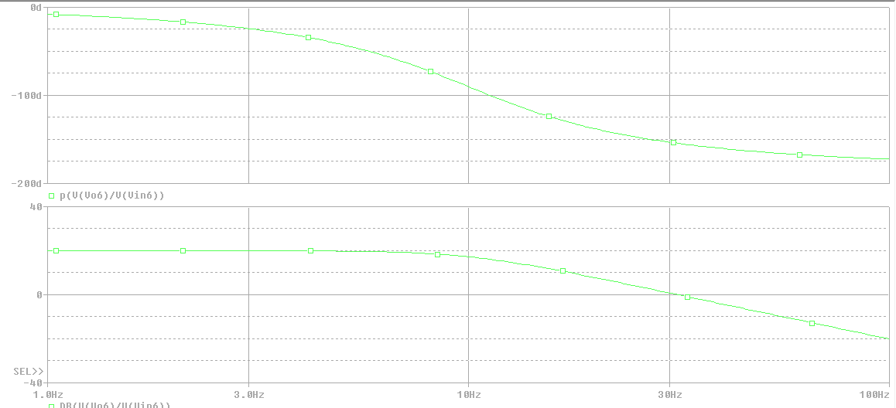

Figure 6.2: Phase Plot (top) and Magnitude Plot (bottom)

7)

K=11

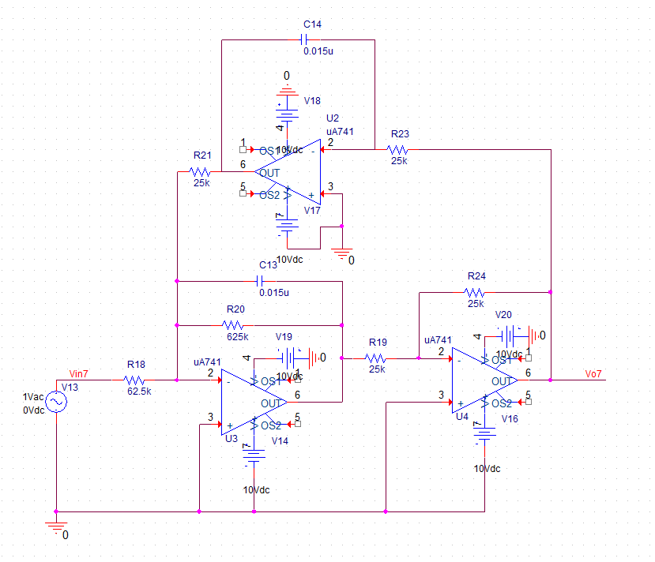

Figure 7.1: Circuit Diagram for Three Op-Amp Biquad Band-Pass Filter

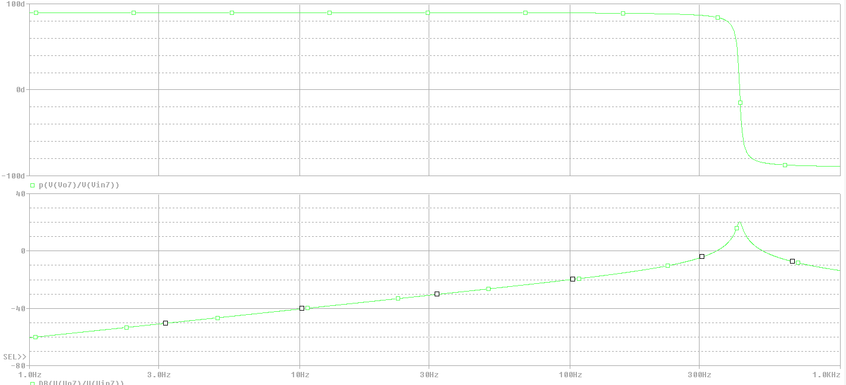

Figure 6.2: Phase Plot (top) and Magnitude Plot (bottom)

**Butterworth**

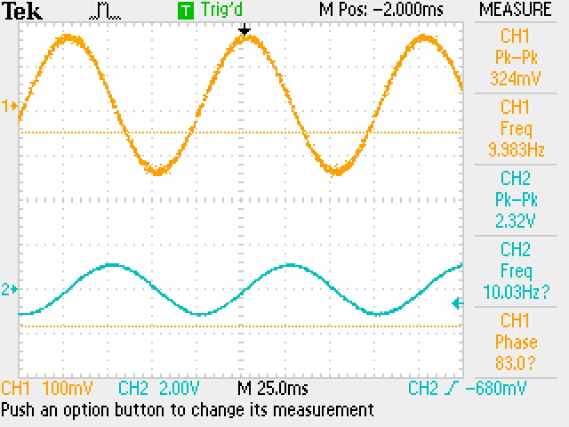

Figure 7.1 Butterworth circuit input (Ch1) vs output (Ch2)

Figure 7.2 Butterworth circuit input Magnitude vs Frequency

The plot of the magnitude of the frequency response of the Butterworth circuit actually mirrors the simulation quite well. Both start with a gain of about 20 dB and a cutoff of roughly 10Hz and a slope of roughly -20db/decade. The slight difference are also due to the slightly different circuit design between Susan’s, whose was tested and mine.

Figure 7.3 Butterworth circuit input Phase vs Frequency

The phase vs frequency of the butterworth does not look like the phase plot of the simulation. This is likely due to an unknown setting on the newer EE wave form genrators or a setting on the very outdated EE osciliscopes. A third possiblity is a flaw in the circuit diagram but this is unlikely due to the proper magnitude response.

